# Form Project Documentation

I am going to be a web interface for a car rental company. The interface is for desktop use and not mobile use. This interface is for the employees, so they can enter the customer data.

## First UI Mookup

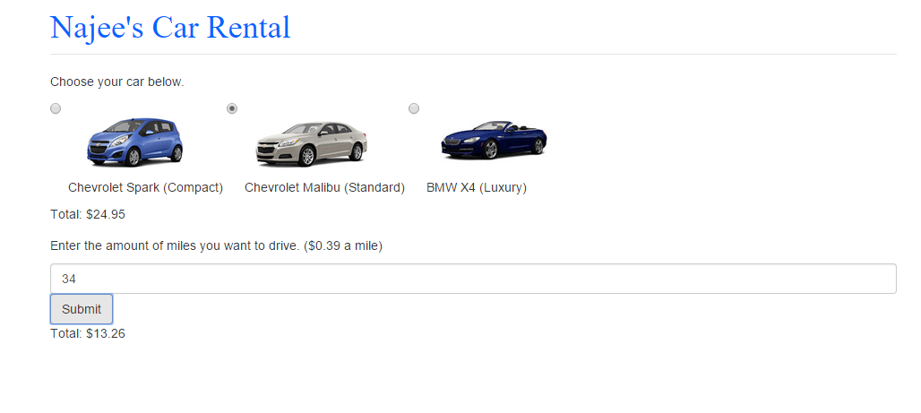

This is just a simple interface that allows you to select the car you want then it prints out the price. One you pick the car you want you enter the miles you want to drive and it is multiply by .39 and printed out on the screen.

## First UI Mookup View

<!DOCTYPE html PUBLIC "-//W3C//DTD XHTML 1.0 Strict//EN" "http://www.w3.org/TR/xhtml1/DTD/xhtml1-strict.dtd">

<html lang="en">

<head>

<title>Najee Car Rental</title>

<meta charset="utf-8">

<meta name="viewport" content="width=device-width, initial-scale=1">

<link rel="stylesheet" href="http://maxcdn.bootstrapcdn.com/bootstrap/3.3.5/css/bootstrap.min.css">

<link href="style.css" rel="stylesheet" type="text/css" />

<script src="https://ajax.googleapis.com/ajax/libs/jquery/1.11.3/jquery.min.js"></script>

<script src="http://maxcdn.bootstrapcdn.com/bootstrap/3.3.5/js/bootstrap.min.js"></script>

<script src="clac.js"></script>

</head>

<body>

<div class="container">

<form id="rentalForm" class="form-horizontal" role="form" onsubmit = "return false;">

<div class="form-group">

<div class="col-sm-offset-2 col-sm-10">

<div class="radio">

<legend><h1>Najee's Car Rental</h1></legend>

<p>Choose your car below.</p>

<label>

<input type="radio" name="userRental" value="compact"onClick="calculateTotal()"> <img src="blue.jpg" /><p>Chevrolet Spark (Compact)</p>

</label>

<label>

<input type="radio" name="userRental" value="standard" onClick="calculateTotal()"> <img src="grey.jpg" /><p>Chevrolet Malibu (Standard)</p>

</label>

<label>

<input type="radio" name="userRental" value="luxury" onClick="calculateTotal()"> <img src="m5.jpg" /><p>BMW X4 (Luxury)</p>

</label>

</div>

<div id="total"></div>

</div>

</div>

<div class="form-group">

<div class="col-sm-offset-2 col-sm-10">

<p>Enter the amount of miles you want to drive. ($0.39 a mile)</p>

<input type="text" class="form-control" name="usr" id="usr">

<button type="submit" id='submit' value='Submit'class="btn btn-default" onclick="calculateMileage()">Submit</button>

<div id="total2"></div>

</div>

</div>

</form>

</div>

</body>

</html>

## First UI Mookup JS

var rental = new Array();

rental["compact"]=19.95;

rental["standard"]=24.95;

rental["luxury"]=39.95;

function getRentalCost()

{

var rentalCost = 0;

var carForm = document.forms["rentalForm"];

var selectedCar = carForm.elements["userRental"];

for (var i = 0; i < selectedCar.length; i++) {

if(selectedCar[i].checked){

rentalCost = rental[selectedCar[i].value];

break;

}

}

return rentalCost;

}

function calculateMileage(){

var carForm = document.forms["rentalForm"];

var test = carForm.elements["usr"].value;

var miles = test *.39;

var total2 = document.getElementById('total2');

total2.style.display='block';

total2.innerHTML = "Total: $"+miles;

}

function calculateTotal()

{

var rentalPrice = getRentalCost();

var total = document.getElementById('total');

total.style.display='block';

total.innerHTML = "Total: $"+rentalPrice;

}

function hideTotal(){

var total = document.getElementById('total');

total.style.display='none';

}

## Final UI Mookup

For the final website I decide to add a login page so employees could access the web interface. Employees would use their employee ID to login and a personal password they created.

## Login page view

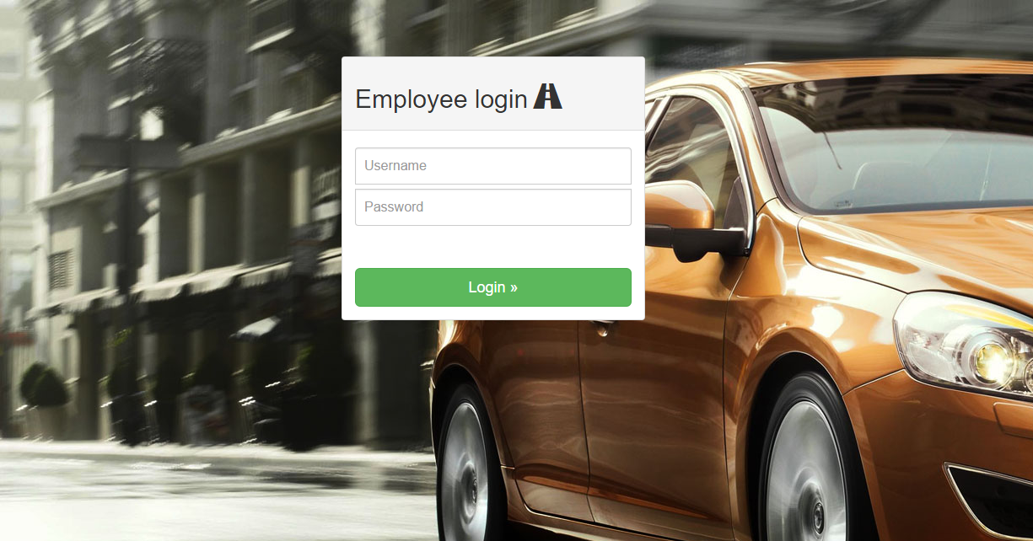

<!DOCTYPE html PUBLIC "-//W3C//DTD XHTML 1.0 Transitional//EN" "http://www.w3.org/TR/xhtml1/DTD/xhtml1-transitional.dtd">

<html xmlns="http://www.w3.org/1999/xhtml">

<head>

<meta http-equiv="Content-Type" content="text/html; charset=utf-8" />

<link href="styles.css" rel="stylesheet" type="text/css" />

<link rel="stylesheet" href="http://maxcdn.bootstrapcdn.com/bootstrap/3.3.5/css/bootstrap.min.css">

<link rel="stylesheet" type="text/css" href="../bootstrap.css" />

<script src="http://mymaplist.com/js/vendor/TweenLite.min.js"></script>

<script src="https://ajax.googleapis.com/ajax/libs/jquery/1.11.3/jquery.min.js"></script>

<script src="../bootstrap.js"></script>

<script src="java.js"></script>

<?php

session_start();

?>

<?php

if( isset($_SESSION['ERRMSG_ARR']) && is_array($_SESSION['ERRMSG_ARR']) && count($_SESSION['ERRMSG_ARR']) >0 ) {

echo '<ul style="padding:0; color:red;">';

foreach($_SESSION['ERRMSG_ARR'] as $msg) {

echo '<li>',$msg,'</li>';

}

echo '</ul>';

unset($_SESSION['ERRMSG_ARR']);

}

?>

<title>Najee's Rental</title>

</head>

<body>

<body>

<div class="container">

<div class="row vertical-offset-100">

<div class="col-md-4 col-md-offset-4">

<div class="panel panel-default">

<div class="panel-heading">

<div class="row-fluid user-row">

<!--<img src="http://s11.postimg.org/7kzgji28v/logo_sm_2_mr_1.png" class="img-responsive" alt="Conxole Admin"/> -->

<h2 class="form-signin-heading">Employee login <span class="glyphicon glyphicon-road"></span></h2>

</div>

</div>

<div class="panel-body">

<form action="login.php" method="POST" accept-charset="UTF-8" role="form" class="form-signin">

<fieldset>

<label class="panel-login">

<div class="login_result"></div>

</label>

<input class="form-control" placeholder="Username" id="username" type="text" name="uname">

<input class="form-control" placeholder="Password" id="password" type="password" name="pword">

<br></br>

<input class="btn btn-lg btn-success btn-block" type="submit" id="login" value="Login »">

</fieldset>

</form>

</div>

</div>

</div>

</div>

</div>

</body>

</div>

</body>

</html>

## Login Page Database

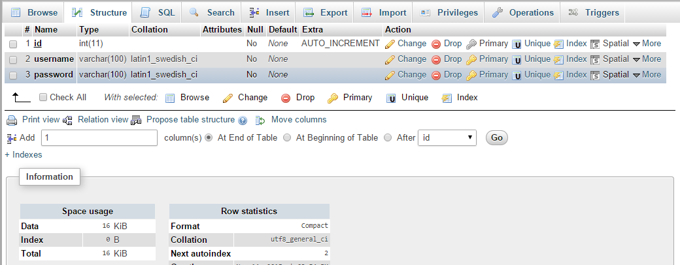

<?php

session_start();

$errmsg_arr = array();

$errflag = false;

// configuration

$dbhost = "localhost";

$dbname = "najeerental";

$dbuser = "root";

$dbpass = "";

// database connection

$conn = new PDO("mysql:host=$dbhost;dbname=$dbname",$dbuser,$dbpass);

// new data

$user = $_POST['uname'];

$password = $_POST['pword'];

if($user == '') {

$errmsg_arr[] = 'You must enter your Username';

$errflag = true;

}

if($password == '') {

$errmsg_arr[] = 'You must enter your Password';

$errflag = true;

}

// query

$result = $conn->prepare("SELECT * FROM users WHERE username= :user AND password= :pass");

$result->bindParam(':user', $user);

$result->bindParam(':pass', $password);

$result->execute();

$rows = $result->fetch(PDO::FETCH_NUM);

if($rows > 0) {

header("location: rentalIndex.php");

}

else{

$errmsg_arr[] = 'Username and Password are not found';

$errflag = true;

}

if($errflag) {

$_SESSION['ERRMSG_ARR'] = $errmsg_arr;

session_write_close();

header("location: index.php");

exit();

}

?>

## Index Page

Once an employee logs in this is the page they see.

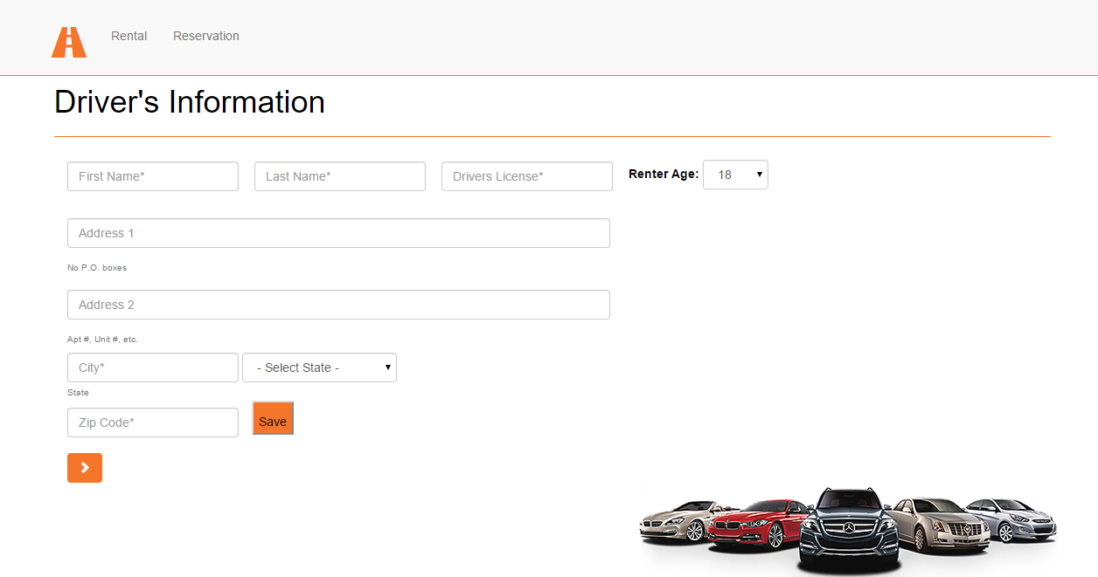

Once they fill out the form all the data is sent to the database.

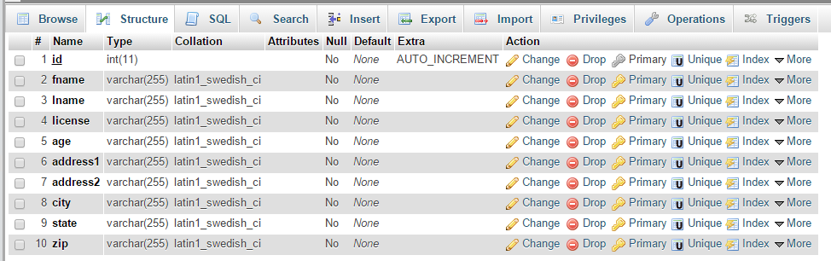

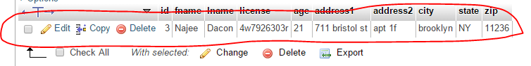(In red is the data I sent over to the database from the form.

After the form is filled out the employee moves to the second step by clicking the orange arrow.

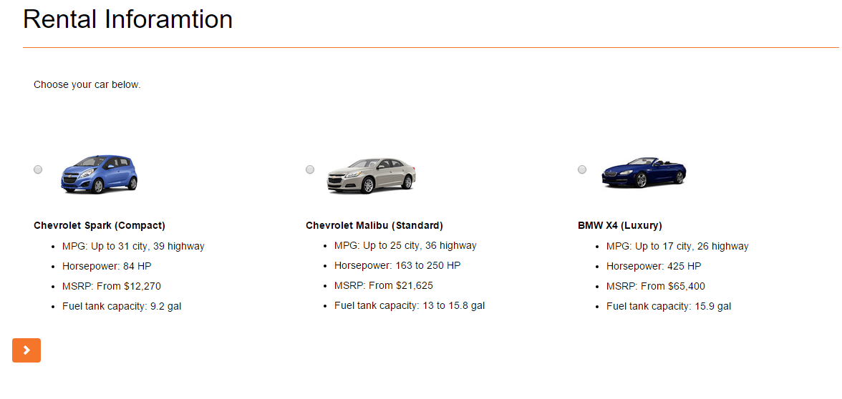

This is where the employee ask the custom what cars are available and they tell the customer the price and the specs. I modify the javascript code from the first mookup and used it for this radio form. Once they select the car the price pops up.

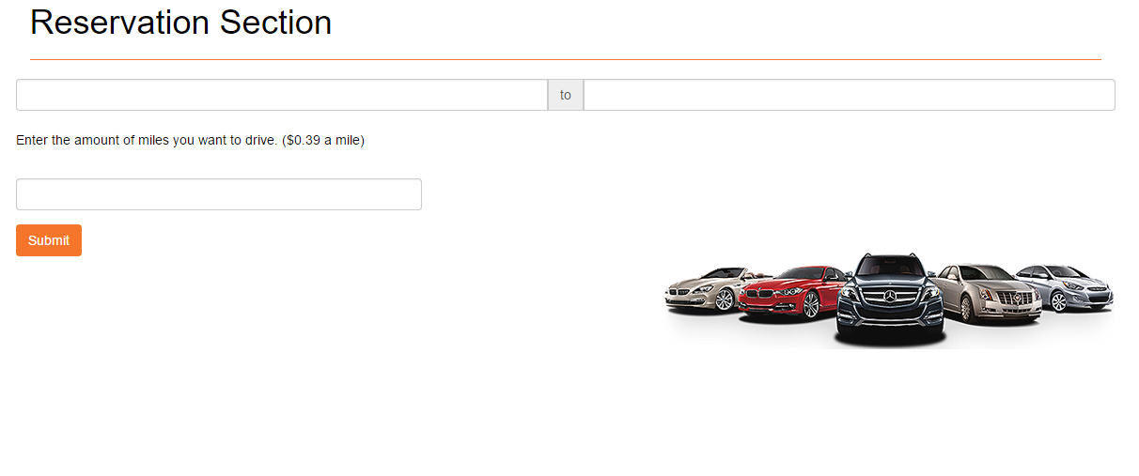

This is the last step the employee ask the customer how long they want the rental for. Once they select the input field to enter data a calendar opens

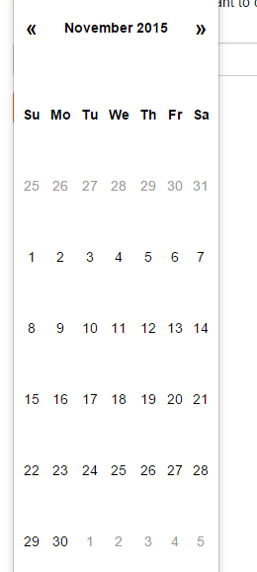And they can just select the data instead of typing it.

## Index View

<!DOCTYPE html>

<html lang="en">

<head>

<meta charset="utf-8">

<meta http-equiv="X-UA-Compatible" content="IE=edge">

<meta name="viewport" content="width=device-width, initial-scale=1">

<meta name="description" content="">

<meta name="author" content="">

<title>Najee's Rentals</title>

<script src="js/jquery.js"></script>

<!-- Bootstrap Core CSS -->

<link href="css/bootstrap.min.css" rel="stylesheet">

<link rel="stylesheet" href="css/datepicker.css">

<!-- Custom CSS -->

<link href="css/scrolling-nav.css" rel="stylesheet">

<!-- HTML5 Shim and Respond.js IE8 support of HTML5 elements and media queries -->

<!-- WARNING: Respond.js doesn't work if you view the page via file:// -->

<!--[if lt IE 9]>

<script src="https://oss.maxcdn.com/libs/html5shiv/3.7.0/html5shiv.js"></script>

<script src="https://oss.maxcdn.com/libs/respond.js/1.4.2/respond.min.js"></script>

<![endif]-->

<script src="clac.js"></script>

<script src="js/main.js"></script>

<script src="js/bootstrap-datepicker.js"></script>

</head>

<!-- The #page-top ID is part of the scrolling feature - the data-spy and data-target are part of the built-in Bootstrap scrollspy function -->

<body id="page-top" data-spy="scroll" data-target=".navbar-fixed-top">

<!-- Navigation -->

<nav class="navbar navbar-default navbar-fixed-top" role="navigation">

<div class="container">

<a class="navbar-brand page-scroll" href="#page-top"><span class="glyphicon glyphicon-road"></a>

<!-- Collect the nav links, forms, and other content for toggling -->

<div class="collapse navbar-collapse navbar-ex1-collapse">

<ul class="nav navbar-nav">

<!-- Hidden li included to remove active class from about link when scrolled up past about section -->

<li class="hidden">

<a class="page-scroll" href="#page-top"></a>

</li>

<li>

<a class="page-scroll" href="#about">Rental</a>

</li>

<li>

<a class="page-scroll" href="#services">Reservation</a>

</li>

</ul>

</div>

<!-- /.navbar-collapse -->

</div>

<!-- /.container -->

</nav>

<!-- Intro Section -->

<section id="intro" class="intro-section">

<div class="container">

<div class="row">

<div class="col-lg-12" style="margin-top: -4em;">

<h1>Driver's Information</h1>

<hr>

<div class="container-fluid" style="margin-top: -56px;">

<div class="row">

<div class="col-md-12">

<?php

session_start();

?>

<?php

if( isset($_SESSION['ERRMSG_ARR']) && is_array($_SESSION['ERRMSG_ARR']) && count($_SESSION['ERRMSG_ARR']) >0 ) {

echo '<ul style="padding:0; color:red;">';

foreach($_SESSION['ERRMSG_ARR'] as $msg) {

echo '<li>',$msg,'</li>';

}

echo '</ul>';

unset($_SESSION['ERRMSG_ARR']);

}

?>

<form role="form" class="form-inline" action="formDriver.php" method="POST">

<div class="form-group">

<input type="text" class="form-control" placeholder = "First Name*" id="exampleInputEmail1" name="fname"/>

</div>

<div class="form-group">

<input type="text" class="form-control" placeholder = "Last Name*" id="exampleInputPassword1" name="lname"/>

</div>

<div class="form-group">

<input type="text" class="form-control" placeholder = "Drivers License*" id="exampleInputEmail1" name="license"/>

</div>

<div class="form-group">

<label for="sel1">Renter Age:</label>

<select class="form-control" id="sel1" name="age">

<option>18</option>

<option>19</option>

<option>20</option>

<option>21</option>

<option>22</option>

<option>23</option>

<option>24</option>

<option>25+</option>

</select>

</div>

<div class="">

<input type="text" class="form-control" placeholder = "Address 1" id="exampleInputEmail12" name="address1" />

<span class="help-block">No P.O. boxes</span>

<input type="text" class="form-control" placeholder = "Address 2" id="exampleInputEmail12" name="address2" />

<span class="help-block">Apt #, Unit #, etc.</span>

</div>

<div class="form-group2">

<input type="text" class="form-control" placeholder = "City*" id="cityMar" name="city"/>

<select class="form-control" id="state" name="state">

<option value="">- Select State -</option>

<option value="AL">Alabama</option>

<option value="AK">Alaska</option>

<option value="AZ">Arizona</option>

<option value="AR">Arkansas</option>

<option value="CA">California</option>

<option value="CO">Colorado</option>

<option value="CT">Connecticut</option>

<option value="DE">Delaware</option>

<option value="DC">District Of Columbia</option>

<option value="FL">Florida</option>

<option value="GA">Georgia</option>

<option value="HI">Hawaii</option>

<option value="ID">Idaho</option>

<option value="IL">Illinois</option>

<option value="IN">Indiana</option>

<option value="IA">Iowa</option>

<option value="KS">Kansas</option>

<option value="KY">Kentucky</option>

<option value="LA">Louisiana</option>

<option value="ME">Maine</option>

<option value="MD">Maryland</option>

<option value="MA">Massachusetts</option>

<option value="MI">Michigan</option>

<option value="MN">Minnesota</option>

<option value="MS">Mississippi</option>

<option value="MO">Missouri</option>

<option value="MT">Montana</option>

<option value="NE">Nebraska</option>

<option value="NV">Nevada</option>

<option value="NH">New Hampshire</option>

<option value="NJ">New Jersey</option>

<option value="NM">New Mexico</option>

<option value="NY">New York</option>

<option value="NC">North Carolina</option>

<option value="ND">North Dakota</option>

<option value="OH">Ohio</option>

<option value="OK">Oklahoma</option>

<option value="OR">Oregon</option>

<option value="PA">Pennsylvania</option>

<option value="RI">Rhode Island</option>

<option value="SC">South Carolina</option>

<option value="SD">South Dakota</option>

<option value="TN">Tennessee</option>

<option value="TX">Texas</option>

<option value="UT">Utah</option>

<option value="VT">Vermont</option>

<option value="VA">Virginia</option>

<option value="WA">Washington</option>

<option value="WV">West Virginia</option>

<option value="WI">Wisconsin</option>

<option value="WY">Wyoming</option>

</select>

<span class="help-block" id="stateMar">State</span>

<input type="text" class="form-control" placeholder = "Zip Code*" name="zip"/> <input id="save" type="submit" value="Save" />

</div>

<a class="btn btn-default page-scroll" href="#about"><span class="glyphicon glyphicon-chevron-right"></span></a>

</form>

<img id="logo" alt="company logo" src="img/rentals.png">

</div>

</div>

</div>

</div>

</div>

</div>

</section>

<!-- About Section -->

<section id="about" class="about-section">

<div class="container">

<div class="row">

<div class="col-lg-12">

<h1>Rental Inforamtion</h1>

<hr>

<div class="container-fluid">

<p>Choose your car below.</p>

<div class="row">

<form id="rentalForm" class="form-horizontal" role="form" onsubmit = "return false;">

<div class="col-sm-4">

<label>

<input type="radio" name="userRental" value="compact"onClick="calculateTotal()">

<img src="img/blue.jpg" alt="blue Chevrolet Spark "/><p>Chevrolet Spark (Compact)</p>

<div class="info">

<ul>

<li> MPG: Up to 31 city, 39 highway </li>

<li> Horsepower: 84 HP </li>

<li> MSRP: From $12,270 </li>

<li> Fuel tank capacity: 9.2 gal </li>

</ul>

</div>

</label>

</div>

<div class="col-sm-4">

<label>

<input type="radio" name="userRental" value="standard"onClick="calculateTotal()">

<img src="img/grey.jpg" alt"gray Chevrolet Malibu"/><p>Chevrolet Malibu (Standard)</p>

<div class="info">

<ul>

<li> MPG: Up to 25 city, 36 highway </li>

<li> Horsepower: 163 to 250 HP</li>

<li> MSRP: From $21,625 </li>

<li> Fuel tank capacity: 13 to 15.8 gal</li>

</ul>

</div>

</label>

</div>

<div class="col-sm-4">

<label>

<input type="radio" name="userRental" value="luxury"onClick="calculateTotal()">

<img src="img/m5.jpg" alt="blue BMW M5" /><p>BMW X4 (Luxury)</p>

<div class="info">

<ul>

<li> MPG: Up to 17 city, 26 highway </li>

<li> Horsepower: 425 HP</li>

<li> MSRP: From $65,400 </li>

<li> Fuel tank capacity: 15.9 gal</li>

</ul>

</div>

</label>

</div>

</div><div id="total" style="display: block;color: red;"></div>

</div>

</div>

<a class="btn btn-default page-scroll" href="#services"><span class="glyphicon glyphicon-chevron-right"></span></a>

</div>

</div>

</div>

</form>

</section>

<!-- Services Section -->

<section id="services" class="services-section">

<div class="container">

<div id="rowMar" class="row">

<div class="col-lg-12">

<h1>Reservation Section</h1>

<hr>

</div>

<div id="serMar2">

<div class="input-group input-daterange">

<input type="text" class="form-control" >

<span class="input-group-addon">to</span>

<input type="text" class="form-control" >

</div>

<form id="rentalForm2" class="form-horizontal" role="form" onsubmit = "return false;">

<p>Enter the amount of miles you want to drive. ($0.39 a mile)</p>

<input type="text" class="form-control" name="usr" id="usr">

<button type="submit" id='submit' value='Submit'class="btn btn-default" onclick="calculateMileage()">Submit</button>

<div id="total2"></div>

</form>

<img id="logo" alt="company logo" src="img/rentals.png">

</div>

</div>

</div>

</section>

<!-- jQuery -->

<!-- Bootstrap Core JavaScript -->

<script src="js/bootstrap.min.js"></script>

<!-- Scrolling Nav JavaScript -->

<script src="js/jquery.easing.min.js"></script>

<script src="js/scrolling-nav.js"></script>

</body>

</html>

<script>

$('.input-daterange input').each(function() {

$(this).datepicker("clearDates");

});

</script>

## Index Database Connection

<?php

session_start();

$errmsg_arr = array();

$errflag = false;

// configuration

$dbhost = "localhost";

$dbname = "najeerental";

$dbuser = "root";

$dbpass = "";

// database connection

$conn = new PDO("mysql:host=$dbhost;dbname=$dbname",$dbuser,$dbpass);

// new data

$fname = $_POST['fname'];

$lname = $_POST['lname'];

$license = $_POST['license'];

$age = $_POST['age'];

$address1 = $_POST['address1'];

$address2 = $_POST['address2'];

$city = $_POST['city'];

$state = $_POST['state'];

$zip = $_POST['zip'];

//form validation

if($fname == '') {

$errmsg_arr[] = 'You must enter your First Name';

$errflag = true;

}

if($lname == '') {

$errmsg_arr[] = 'You must enter your Last Name';

$errflag = true;

}

if($license == '') {

$errmsg_arr[] = 'You must enter your Driver License';

$errflag = true;

}

if($address1 == '') {

$errmsg_arr[] = 'You must enter your Address';

$errflag = true;

}

if($city == '') {

$errmsg_arr[] = 'You must enter your City';

$errflag = true;

}

if($zip == '') {

$errmsg_arr[] = 'You must enter your Zip';

$errflag = true;

}

if($errflag) {

$_SESSION['ERRMSG_ARR'] = $errmsg_arr;

session_write_close();

header("location: rentalIndex.php");

exit();

}

// query

$sql = "INSERT INTO driverinfo (fname,lname,license,age,address1,address2,city,state,zip)

VALUES (:sas,:asas,:alicense,:aage,:aaddress1,:aaddress2,:acity,:astate,:azip)";

$q = $conn->prepare($sql);

$q->execute(array(':sas'=>$fname,':asas'=>$lname, ':alicense'=>$license, ':aage'=>$age,':aaddress1'=>$address1,':aaddress2'=>$address2,

':acity'=>$city,':astate'=>$state,':azip'=>$zip));

header("location: rentalIndex.php");

?>

## Index JavaScript

var rental = new Array();

rental["compact"]=19.95;

rental["standard"]=24.95;

rental["luxury"]=39.95;

function getRentalCost()

{

var rentalCost = 0;

var carForm = document.forms["rentalForm"];

var selectedCar = carForm.elements["userRental"];

for (var i = 0; i < selectedCar.length; i++) {

if(selectedCar[i].checked){

rentalCost = rental[selectedCar[i].value];

break;

}

}

return rentalCost;

}

function calculateMileage(){

var carForm = document.forms["rentalForm2"];

var test = carForm.elements["usr"].value;

var miles = test *.39;

var total2 = document.getElementById('total2');

total2.style.display='block';

total2.innerHTML = "Total: $"+miles;

}

function calculateTotal()

{

var rentalPrice = getRentalCost();

var total = document.getElementById('total');

total.style.display='block';

total.innerHTML = "Total: $"+rentalPrice;

}

function hideTotal(){

var total = document.getElementById('total');

total.style.display='none';

}